

**Company analysis report**

**Retail Industry**

**J Sainsbury Plc and Tesco Plc**

**Portfolio Task 3: The Industry Analysis and Ethics**

**Module Name: Project -Finance and Investment**

**Table of Contents**

**Introduction: Overview of the UK Supermarket Industry** 3

**Market Value and Volume** 3

**Geographical Segmentation** 4

**Key Players** 5

**Market Trends** 6

**Porter’s Five Forces Analysis of the UK Supermarket Industry** 7

**References** 10

# **Introduction: Overview of the UK Supermarket Industry**

The supermarket industry is one of the largest industries in the UK having 70% market share and is one of the most saturated and competitive industries in terms of revenues and continuous innovations. Significantly, the two UK’s largest supermarket chains Tesco and Sainsbury’s having 26% and 15% market share respectively, have been chosen as the focus of this research. In the market, competition is quite intense and there are a few large players like Asda having 13% market share, Aldi having 10% and Morrison having 8.7% market share respectively; the revenues, nonetheless, are high and the market is always looking to find ways to improve the ways things are done. (Zhou, 2024). This report aims to ascertain the market value of the industry, its geographical segmentation, the current players in the market and the trends. Further, the industry analysis based on Porter’s Five Force model provides an insight on the competition forces, threats and the bargaining powers in the industry.

## **UK industry analysis and ethics**

There are several ethical issues that UK supermarkets are currently facing. Other environmental concerns are: plastic packaging waste (5 million tons per annum) and food waste (10 million tons per annum estimated) (Olarewaju et al. 2024). Potential problems concerning labor rights include possible low pay and long hours for some workers. Data issues are also important, as supermarkets gather a significant amount of information about their customers, and the appropriate handling of such data is an issue.

## **Market Value and Volume**



The supermarket industry in the UK is expected to rise gradually from the total market value of £234.8 billion in 2024 to £274.3 billion by 2029, with a CAGR of 3.0%. This persistent increase suggests a healthy and growing industry with regular yearly additions to the market value between 2.9% and 3.2% (IBIS, 2024).

## **Geographical Segmentation**

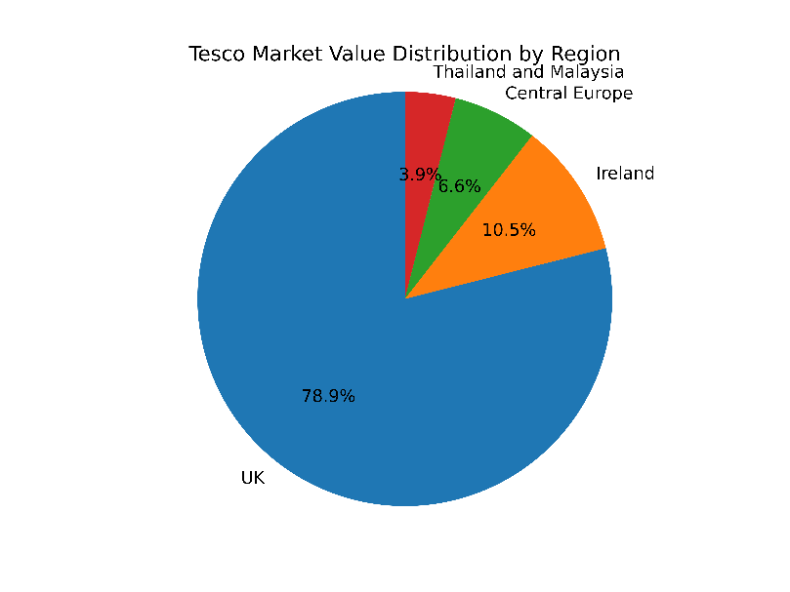

Tesco Plc is amongst the UK’s leading supermarket chains with extensive market shares across the world (Statista, 2024b). The UK market is worth £60 billion, up 2% while the Ireland market is worth €8 billion, up 1.5% and the Central Europe; Poland, Hungary and Slovakia are worth €5 billion, up 1%. In Thailand and Malaysia only, the market value is £3 billion which has reduced by 0.5%.

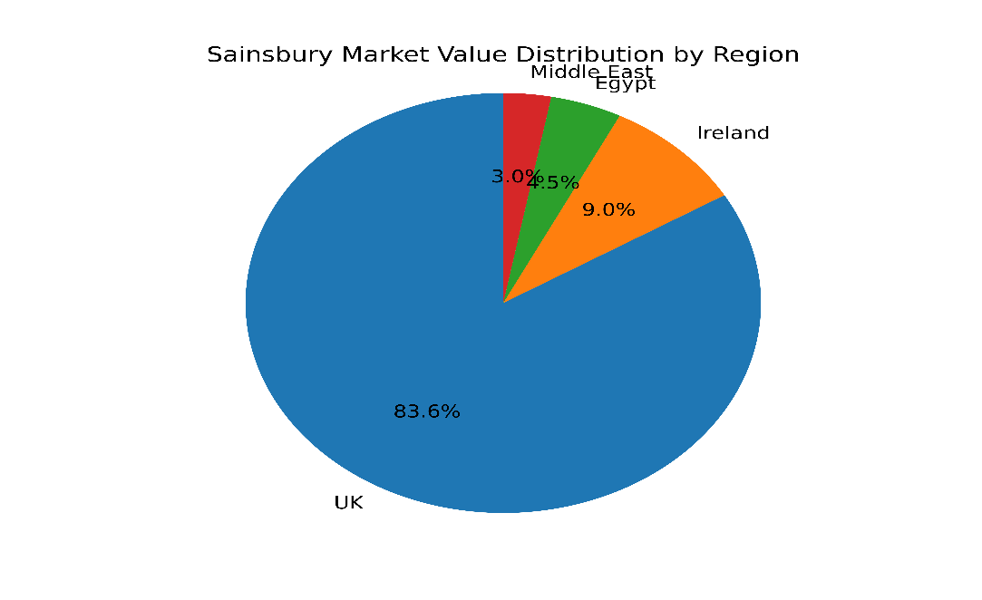

Sainsbury supermarket chain is a big supermarket chain in UK and its market value in UK is £28 billion (1.8%) and in Ireland €9 billion (1.2%). In Egypt it invests £4.5 billion (up 3%). Nonetheless, Middle East, particularly Qatar and UAE, it slightly declines to £1 billion; a 0.7% drop leading to 3.0% (Sainsbury Annual Report, 2023).

## **Key Players**

**1. Tesco:**

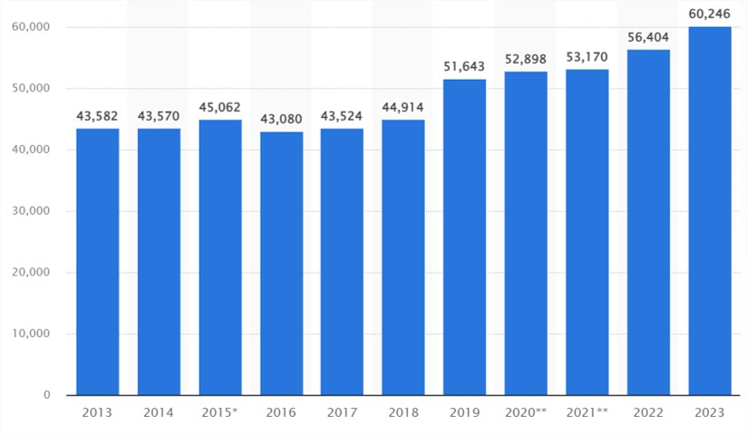

**Figure 1 shows: Annual Revenue of Tesco (Statista, 2024b)**

Tesco takes the largest market share in the UK with 26% (Statista, 2024a). The total income of them is £60,246 billion, supported by a solid store infrastructure of 799 shops and a successful Internet company (Statista, 2024b). Tesco has a wide product portfolio and has undertaken various measures for sustainability: the company does not use plastic bags and has reduced carbon emissions. They also have urban convenience store formats to meet the demands of the urban population.

**2. Sainsbury’s:**

Sainsbury’s follows Tesco and is another dominant supermarket in the UK, controlling 15% of market share. It generates more than £30 billion in annual sales, leverages a robust online platform, and delivers high-quality, sustainable goods. They are committed to environmental stewardship; they support the WWF campaign to cut the ecological footprint of a UK grocery basket to half by 2030 as a part of 1.5°C climate targets (Sainsbury Sustainability Report, 2023).

**3. Other Competitors:**

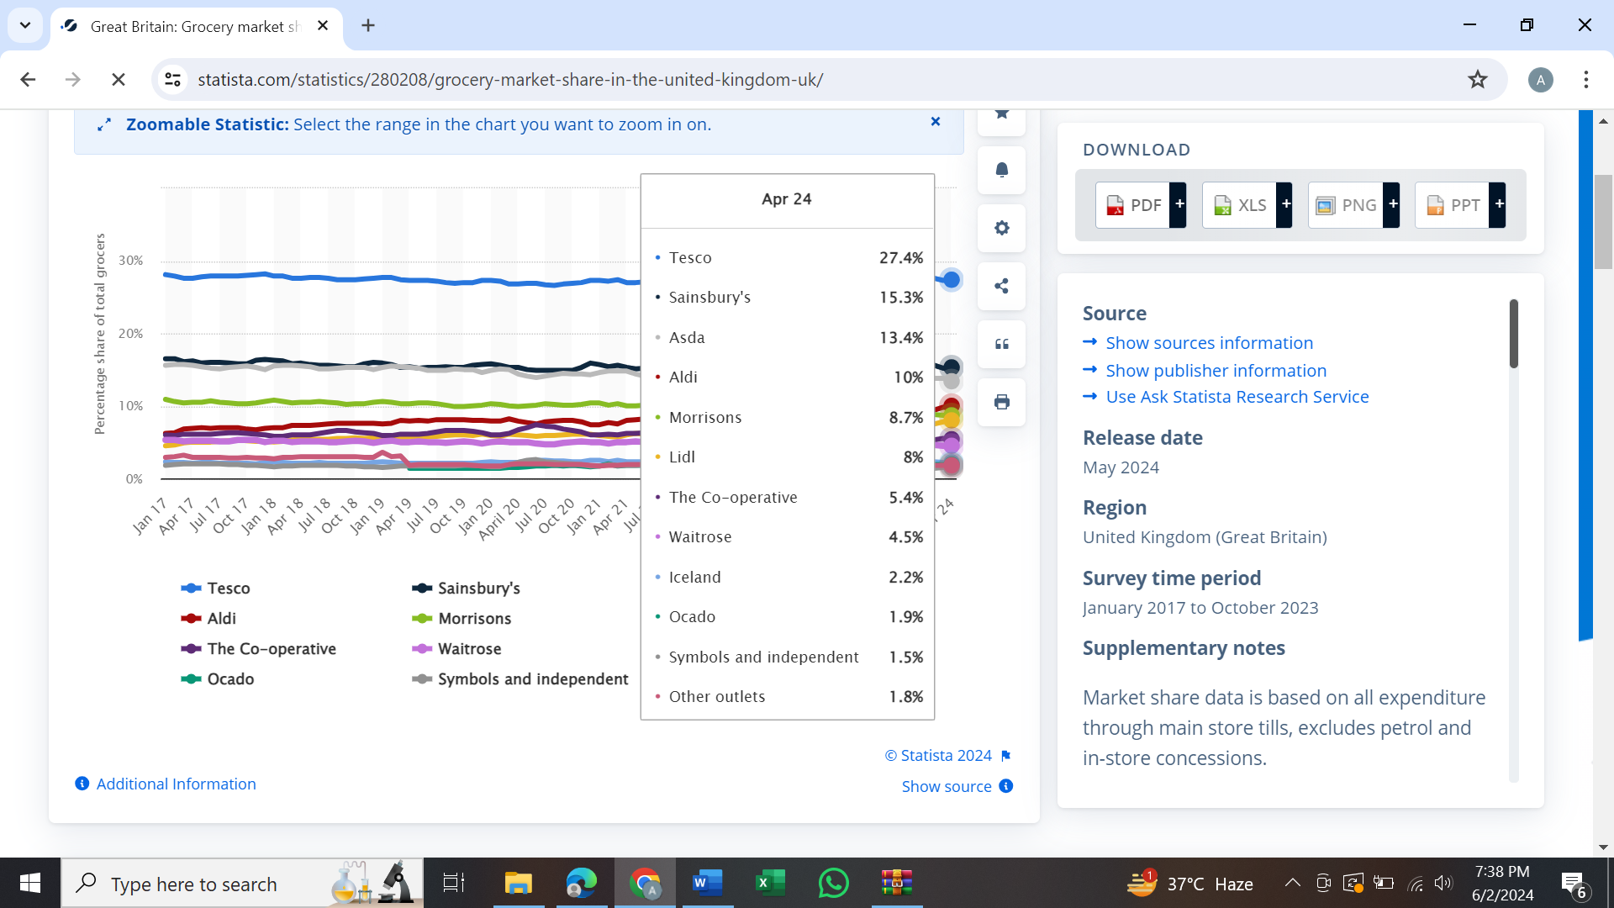

**Figure 2 shows: UK Major supermarkets Revenue (Statista, 2024c)**

* **Asda:** It enjoys a fairly large market share of 13.4%, along with that the company’s policy to offer relatively low prices, has been noticed.
* **Morrisons:** Having market share of 8.7% itspecializes in products and has a new type of supply chain that is integrated vertically.
* **Aldi and Lid:** The new entrants running cut—price food stores that have captured a significant market share of 10% & 8% respectively due to their low costs and high productivity (Statista, 2024c).
* **Waitrose:** Concentrating on the niche audience of wealthy consumers, stressing the concepts of quality and superior service. Waitrose have market share of 4.5% in UK market.

## **Market Trends**

Several key trends are shaping the UK supermarket industry:

**1. Online Grocery Shopping:** The COVID-19 outbreak significantly affects the world and made them buy products online more often and diversely. The two giants, Tesco and Sainsbury’s, for instance, have endeavored to expand the capabilities of their e-commerce facilities to serve this need.

**2. Sustainability:** The awareness of the environmental products and practices has gradually been incorporated as an essential factor to consumers. Supermarkets are cutting down their plastic consumption, looking for more environmentally friendly options, and encouraging customers to buy products that supports nature (Kemper et al. 2024).

**3. Health and Wellness:** Currently, the consumption of organic food, natural food and food free from certain non-environment friendly compounds has been on the rise. Supermarkets are increasing their products’ variety for health-conscious customers. Tesco has been reformulating its own-brand goods to cut sugar, salt, and fat levels. Tesco has eliminated chocolate and sweets from checkouts and replaced them with healthier options. Sainsbury's has also been actively decreasing sugar, salt, and fat in its own-brand items. Using traffic light labeling, buyers can readily identify healthier products.

**4. Technology Integration:** Application of AI to create value, improve customer satisfaction, and reduce costs and creativity of supply channels is gaining ground. Like implication of automated checkout, mobile apps for personalized promotions.

In conclusion the UK supermarket industry is highly competitive and rapidly growing industry with immense market value, forecasted to reach £274.3 billion in 2029 (Mintel, 2023).

# **Porter’s Five Forces Analysis of the UK Supermarket Industry**

**1. Competitive Rivalry (High)**

The competition in the UK supermarket industry is high and presently there are many players in the industry along with many potential entrants and is mainly dominated by several large players including Tesco, Sainsbury’s, Asda, Morrisons, Aldi and Lidl. This has resulted in increased rivalry, which results to price cutting, regular offers and promotions, and large amounts of expenditure on delivery of value to customer (Clark et al. 2020). Stores are improving their service delivery methods through approaches like automation of checkouts, tailored shopping experiences, diversification of formats that better suit the local markets, and new product categories, including organic and environmentally friendly products. For example, Tesco organized the Clubcard Plus subscription service providing benefits and savings; Aldi adds new organic and vegan products to its offerings due to consumers’ trend changes.

**2. Threat of New Entrants (Low to Moderate):**

There are major barriers to entry in the supermarket industry that include the capital investment needed to break in, supply chain infrastructure, and brand awareness. The current players have advantage of brand association and the gaining of volumes of sales hence making it difficult for new players to penetrate the market. However, there is a moderate threat from new entrants, specifically the niche markets and the online grocery startups like Ocado and HelloFresh providing online delivery and meal kits, respectively, since they can easily target different segments based on their needs or provide different propositions.

**3. Suppliers’ bargaining power (Low):**

To start with, the bargaining power of suppliers in the UK supermarket industry is considered to be low. Supermarket giants like Tesco and Sainsbury’s have the power of bargaining since they are large buyers with large volumes of products they need from suppliers. Tesco & Sainsbury can negotiate for lower price and demand better quality goods from the suppliers due to their bulk purchasing (Prapha and Ivanhoe, 2022). Further, the bargaining power of suppliers can be reduced by the fact that consumers can change supermarket suppliers several times. However, exclusive or luxury products suppliers may have slightly higher power to bargain than other parties.

**4. Bargaining Power of Buyers (High):**

The bargaining power of consumers in the UK supermarket industry is high because of the availability of many choices and easy switching between industries. High volatility is another issue as it is caused by customer’s desire to obtain the best price, promotions and discounts, which directed to frequent changes in their behavior. Supermarkets do this by offering loyalty programs like Tesco Clubcard and Sainsbury's Nectar Card offering personalized prices to its customers which helps to minimize the bargaining power of these consumers. Specifically, continued advancement in the technology that supports online shopping has helped put more power in the hands of consumers by offering more comparative pricing information on the other side resulting in a major disadvantage to supermarkets.

**5. Threat of substitutes (Moderate to High):**

The supermarket industry is moderately to highly threatened by the presence of substitutes such as online grocery delivery services, convenience stores, discount retailers and local markets. Customers also have choice options for the procurement of their groceries which include the traditional grocery stores, convenience stores, specialty stores, farmers’ markets and even online grocery stores (Abumalloh et al. 2023). Another threat is the growth of niche players, such as meal kits and direct-to-consumer food companies. To counter this, supermarkets are diversifying their product portfolio by adding more of organic and niche food products, improving their online grocery shopping platforms, and continuing to offer services such as click-and-collect and delivery at homes to customers.

Thus, the application of Porter’s Five Forces shows that the UK supermarket industry has a high level of competition due to high buyer power and threat of substitution. However, low supplier power and high entry barriers ensure sustained competitively within the market.

# **References**

Abumalloh, R.A., Nilashi, M., Ooi, K.B., Wei-Han, G., Cham, T.H., Dwivedi, Y.K. and Hughes, L., 2023. The adoption of metaverse in the retail industry and its impact on sustainable competitive advantage: moderating impact of sustainability commitment. *Annals of Operations Research*, pp.1-42. **DOI** [10.1007/s10479-023-05608-8](http://dx.doi.org/10.1007/s10479-023-05608-8)

Clark, H., Royal, P., West, H., Clothier, S., Smith, S., Chui, B., Howells, K., Hodgson, C., Porter, L., Albon, D. and Bagnall, P., (2020). Healthy families: the present and future role of the supermarket.

IBIS, (2024). <https://www.ibisworld.com/united-kingdom/market-research-reports/supermarkets-industry/#:~:text=Market%20share%20concentration%20of%20the,the%20United%20Kingdom%20is%2030%25>. (Accessed date: 3 June, 2024)

Kemper, J.A., Spotswood, F. and White, S.K., (2024). The emergence of plastic-free grocery shopping: Understanding opportunities for practice transformation. Journal of Environmental Management, 349, p.119290.

Mintel, (2023). <https://store.mintel.com/report/uk-supermarkets-market-report#:~:text=UK%20Supermarket%20Industry%20%E2%80%93%20Current%20Landscape&text=UK%20grocery%20retail%20market%20size,%C2%A3241.3%20billion%20in%202028> (Accessed date: 28 May, 2024)

Prapha, A. and Ivanhoe, H., (2022). Turning Point: A three year update on US supermarkets' progress and pitfalls.

Sainsbury Annual Report, (2023). <https://www.about.sainsburys.co.uk/~/media/Files/S/Sainsburys/documents/reports-and-presentations/2023/annual-report-2023/annual-report-and-financial-statements-2023.pdf> (Accessed date: 3 June, 2024)

Sainsbury Sustainability Report, (2023). Report <https://www.about.sainsburys.co.uk/sustainability/better-for-the-planet/carbon> (Accessed date: 28 May, 2024)

Statista, (2024a). <https://www.statista.com/topics/3807/tesco-plc/> (Accessed date: 28 May, 2024)

Statista, (2024b). <https://www.statista.com/statistics/490931/tesco-group-finance-revenue-united-kingdom-uk/> (Accessed date: 28 May, 2024)

Statista, (2024c). <https://www.statista.com/statistics/280208/grocery-market-share-in-the-united-kingdom-uk/> (Accessed date: 28 May, 2024)

Zhou, Z., (2024). Analysis of Representative Stocks in the UK Supermarket Industry. Highlights in Business, Economics and Management, 24, pp.1100-1104.

Olarewaju, T., Dani, S., Obeng-Fosu, C., Olarewaju, T. and Jabbar, A., (2024). The Impact of Climate Action on the Financial Performance of Food, Grocery, and Supermarket Retailers in the UK. Sustainability, 16(5), p.1785.